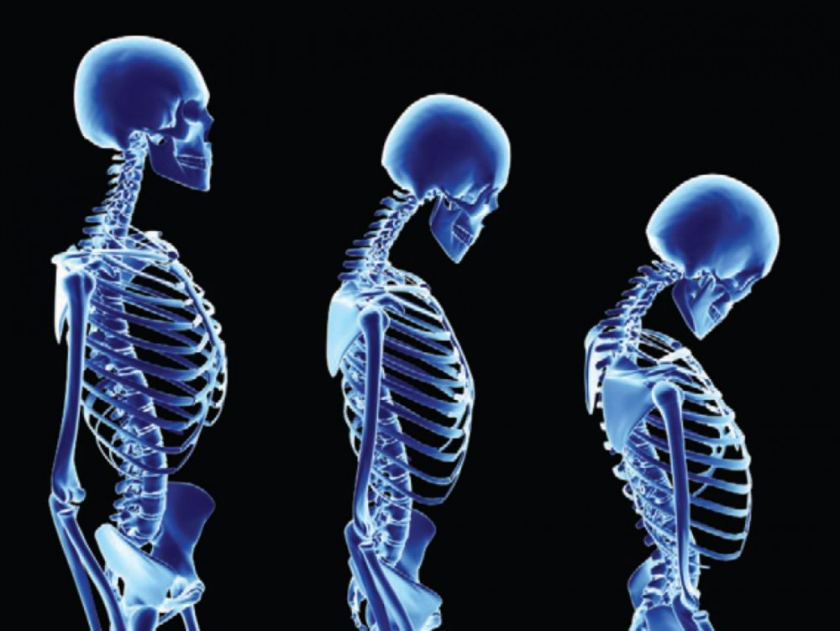
This Photo by Unknown Author is licensed under CC BY-NC

Data on Children who have had Corrective Spinal Surgery

Description
The kyphosis data frame has 81 rows and 4 columns. representing data on children who have had corrective spinal surgery

Format
This data frame contains the following columns:
Kyphosis
a factor with levels absent present indicating if a kyphosis (a type of deformation) was present after the operation.
Age
in months
Number
the number of vertebrae involved
Start
the number of the first (topmost) vertebra operated on.

Source
John M. Chambers and Trevor J. Hastie eds. (1992) Statistical Models in S, Wadsworth and Brooks/Cole, Pacific Grove, CA.

